**NEP**

Q-1).Write a program in Prolog to implement TowerOfHanoi(N) where N represents the number of disks.

**Code**:-

write_move(N,X,Y) :-

write('Move disk'),

write(N),

write(' from '),

write(X),

write(' to '),

write(Y),nl.

move(1, X, Y, _) :-

write_move(1,X,Y).

move(N, X, Y, Z) :-

N > 1,

M is N - 1,

move(M, X, Z, Y), % Move smaller disks to auxiliary rod

write_move(N,X,Y),

% Pr

move(M, Z, Y, X). % Move smaller disks to target rod using auxiliary rod

towers_of_hanoi(N, Source, Target, Aux) :-

move(N, Source, Target, Aux).

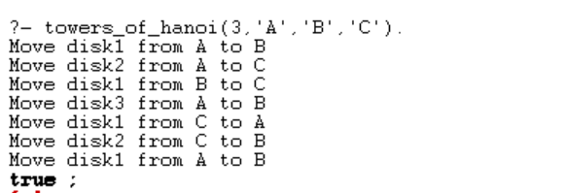

Q8. Write a program to implement the family tree and demonstrate the family relationship.

**Code:-**

/* Define facts about family relationships */

male(john).

male(tom).

male(peter).

male(bob).

female(lisa).

female(anna).

female(susan).

female(emily).

parent(john, tom).

parent(john, lisa).

parent(lisa, anna).

parent(lisa, susan).

parent(tom, peter).

parent(anna, emily).

parent(susan, bob).

/* Define rules to infer other relationships */

father(Father, Child) :-

male(Father),

parent(Father, Child).

mother(Mother, Child) :-

female(Mother),

parent(Mother, Child).

sibling(X, Y) :-

parent(Z, X),

parent(Z, Y),

X \= Y.

**Output:-**

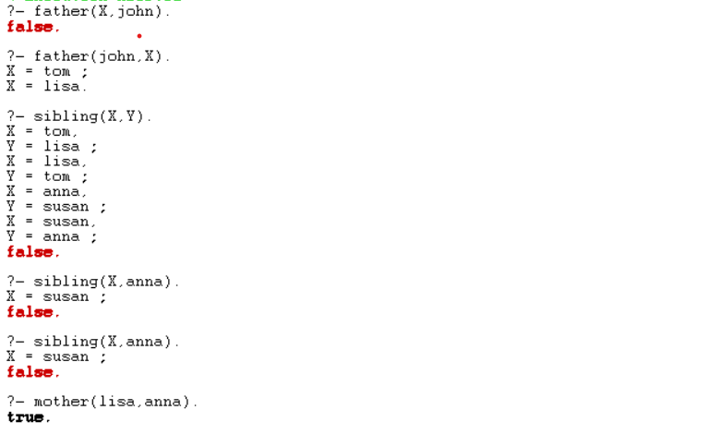

Q-9).Write a prolog program to implement knowledge representation using frames with appropriate examples.

**Code:-**

% Define frames for different types of vehicles

frame(vehicle,

[ slots: [type, brand, model, color, year]

]).

% Specific instances of vehicles

vehicle(car,

[ type: car,

brand: honda,

model: civic,

color: blue,

year: 2018

]).

vehicle(truck,

[ type: truck,

brand: ford,

model: f150,

color: black,

year: 2020

]).

% Define a predicate to query information about a vehicle

vehicle_info(Type, Info) :-

vehicle(Type, Info).



Q-12).Write a Prolog Program to generate parse tree of a given sentence assuming the grammar required for parsing.

**Code:-**

% Define the grammar rules

sentence(S) --> noun_phrase(NP), verb_phrase(VP), { S = [NP, VP] }.

noun_phrase(NP) --> determiner(D), noun(N), { NP = [D, N] }.

verb_phrase(VP) --> verb(V), noun_phrase(NP), { VP = [V, NP] }.

determiner(the) --> [the].

determiner(a) --> [a].

noun(cat) --> [cat].

noun(dog) --> [dog].

verb(chases) --> [chases].

% Parse function

parse(Sentence, ParseTree) :-

phrase(sentence(ParseTree), Sentence).

**Output:-**

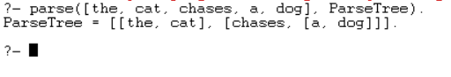

**LOCF**

Q1. Write a prolog program to calculate the sum of two numbers.

**⇒** go:-

    write('Enter a number: '),read(A),nl,

    write('Enter 2nd number: '),read(B),nl,

    C is A+B,

    write('Sum is: '),write(C).

***⇒ Output:***

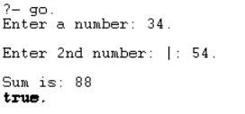

Q2. Write a Prolog program to implement max(X, Y, M) so that M is the maximum of two numbers X and Y.

**⇒** max(A,B,C):- A>B ,C  is A.

max(A,B,C):- A<B,C is B.

***⇒ Output:***

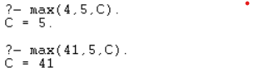

Q3. Write a program in PROLOG to implement factorial (N, F) where F represents the factorial of a number N.

**⇒** factorial(0, 1).

factorial(N, F) :-

    N > 0,

    N1 is N - 1,

    factorial(N1, F1),

    F is N * F1.

***⇒ Output:***



Q4. Write a program in PROLOG to implement generate_fib(N,T) where T represents the Nth term of the fibonacci series.

**⇒** fibonacci(0, 0).

fibonacci(1, 1).

fibonacci(N, T) :-

    N > 1,

    N1 is N - 1,

    N2 is N - 2,

    fibonacci(N1, T1),

    fibonacci(N2, T2),

    T is T1 + T2.

***⇒ Output:***



Q5. Write a Prolog program to implement GCD of two numbers.

**⇒** gcd(X, 0, X) :- X>0.

gcd(X, Y, Z) :- Y>0,

        Y1 is X mod Y,

        gcd(Y, Y1, Z).

cgcd():-

            write("Enter the first number : "), read(X),

            write("Enter the second number : "), read(Y),

            gcd(X,Y,Z),

            write("The GCD is : "), write(Z).

***⇒ Output:***

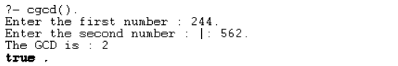

Q6. Write a Prolog program to implement power (Num,Pow, Ans) : where Num is raised to the power Pow to get Ans.

**⇒** pow(_, 0, 1).

pow(N, 1, N).

pow(N, P, A) :-

            P>1,

            P1 is P-1,

            pow(N, P1, A1),

            A is N*A1.

power():-

            write("Enter the number : "), read(X),

            write("Enter the power : "), read(Y),

            pow(X,Y,Z),

write("Answer : "), write(Z).

***⇒ Output:***

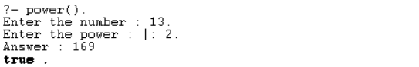

Q7. Prolog program to implement multi (N1, N2, R) : where N1 and N2 denotes the numbers to be multiplied and R represents the result.

**⇒** multi(X, Y, Z) :-

        Z is X*Y.

multiply():-

            write("Enter the first number : "), read(X),

            write("Enter the second number : "), read(Y),

            multi(X,Y,Z),

            write("Product : "), write(Z).

***⇒ Output:***

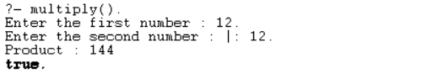

Q8. Write a Prolog program to implement memb(X, L): to check whether X is a member of L or not.

***⇒*** % memb(X, L) checks if X is a member of the list L.

memb(X, [X | _]).

memb(X, [_ | Rest]) :- memb(X, Rest).

***⇒ Output:***

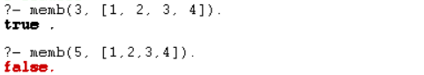

Q9. Write a Prolog program to implement conc (L1, L2, L3) where L2 is the list to be appended with L1 to get the resulted list L3.

**⇒** conc([], L, L).

conc([H|T1], L2, [H|T3]) :- conc(T1, L2, T3).

***⇒ Output:***



Q10. Write a Prolog program to implement reverse (L, R) where List L is original and List R is reversed list.

***⇒*** % Base case: the reverse of an empty list is the empty list

reverse([], []).

reverse([Head|Tail], Reversed) :-

      reverse(Tail, ReversedTail),

       append(ReversedTail, [Head], Reversed).

***⇒ Output:***



Q11. Write a program in PROLOG to implement palindrome (L) which checks whether a list L is a palindrome or not.

***⇒*** % Base case: An empty list is a palindrome.

palindrome([]).

% Recursive case: A list is a palindrome if its first and last elements are the same,

% and the sublist obtained by removing these elements is also a palindrome.

palindrome([_]).

palindrome([H|T]) :- append(Middle, [H], T), palindrome(Middle).

**⇒ *Output:***

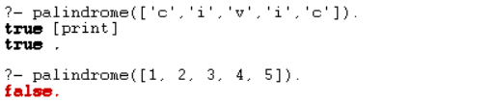

Q12. Write a Prolog program to implement sumlist(L, S) so that S is the sum of a given list L.

***⇒ % Base case: An empty list has a sum of 0.***

sumlist([], 0).

% Recursive case: Sum the head of the list with the sum of the tail.

sumlist([Head|Tail], S) :-

      sumlist(Tail, RestSum),

      S is Head + RestSum.

***⇒ Output:***



Q13. Write a Prolog program to implement two predicates evenlength(List) and oddlength(List) so that they are true if their argument is a list of even or odd length respectively.

***⇒*** % Base case: An empty list has an even length.

evenlength([]).

% Recursive case: A list has an even length if its tail has an odd length.

evenlength([_|T]) :- oddlength(T).

% Base case: A list with a single element has an odd length.

oddlength([_]).

% Recursive case: A list has an odd length if its tail has an even length.

oddlength([_|T]) :- evenlength(T).

***⇒ Output:***

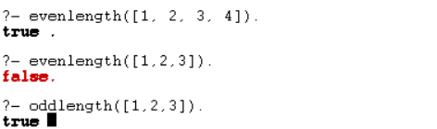

Q14. Write a Prolog program to implement nth_element (N, L, X) where N is the desired position, L is a list and X represents the Nth element of L.

***⇒***%nth_element(N, L, X) succeeds if X is the Nth element of list L.

nth_element(1, [X|_], X). % Base case: X is the first element.

nth_element(N, [_|Rest], X) :-

    N > 1, % Ensure N is positive.

    N1 is N - 1, % Decrement N.

    nth_element(N1, Rest, X). % Recurse on the rest of the list.

% Example usage:

% ?- nth_element(3, [a, b, c, d, e], X).

% X = c

***⇒Output:***



Q15. Write a Prolog program to implement maxlist(L, M) so that M is the maximum number in the list.

**⇒** %maxlist(L, M) succeeds if M is the maximum number in the list L.

maxlist([X], X). % Base case: Single-element list, M is that element.

maxlist([Head|Tail], Max) :-

    maxlist(Tail, TailMax), % Recurse on the tail of the list.

    (Head > TailMax -> Max = Head ; Max = TailMax

% Example usage:

% ?- maxlist([5, 8, 3, 12, 7], Max).

% Max = 12

***⇒Output:***



Q16. Write a prolog program to implement insert_nth (I, N, L, R) that inserts an item I into Nth position of list L to generate a list R.

**⇒** % insert_nth(I, N, L, R) succeeds if R is the list obtained by inserting I at position N in L.

insert_nth(I, 1, L, [I|L]). % Base case: Insert I at the beginning.

insert_nth(I, N, [X|Rest], [X|R]) :-

    N > 1, % Ensure N is positive.

    N1 is N - 1, % Decrement N.

    insert_nth(I, N1, Rest, R). % Recurse on the rest of the list.

***⇒Output:***



Q17. Write a Prolog program to implement delete_nth (N, L, R) that removes the element on Nth position from a list L to generate a list R.

**⇒** % delete_nth(N, L, R) succeeds if R is the list obtained by removing the Nth element from L.

delete_nth(1, [_|Tail], Tail). % Base case: Remove the first element.

delete_nth(N, [X|Rest], [X|R]) :-

    N > 1, % Ensure N is positive.

    N1 is N - 1, % Decrement N.

    delete_nth(N1, Rest, R). % Recurse on the rest of the list.

***⇒ Output:***



Q18. Write a program in PROLOG to implement merge (L1, L2, L3) where L1 is first ordered list and L2 is second ordered list and L3 represents the merged list.

**⇒** % Base case: If both lists are empty, the merged list is also empty.

merge([], [], []).

% If L1 is empty, L3 is simply L2.

merge([], L2, L2).

% If L2 is empty, L3 is simply L1.

merge(L1, [], L1).

% Merge the heads of L1 and L2 into L3.

merge([X | Rest1], [Y | Rest2], [X | Rest3]) :-

    X =< Y, % X is less than or equal to Y

    merge(Rest1, [Y | Rest2], Rest3).

merge([X | Rest1], [Y | Rest2], [Y | Rest3]) :-

    X > Y, % X is greater than Y

    merge([X | Rest1], Rest2, Rest3).

***⇒Output:***

